Step 1 is to connect any device to your bio star by clicking device>search device>select device and then add
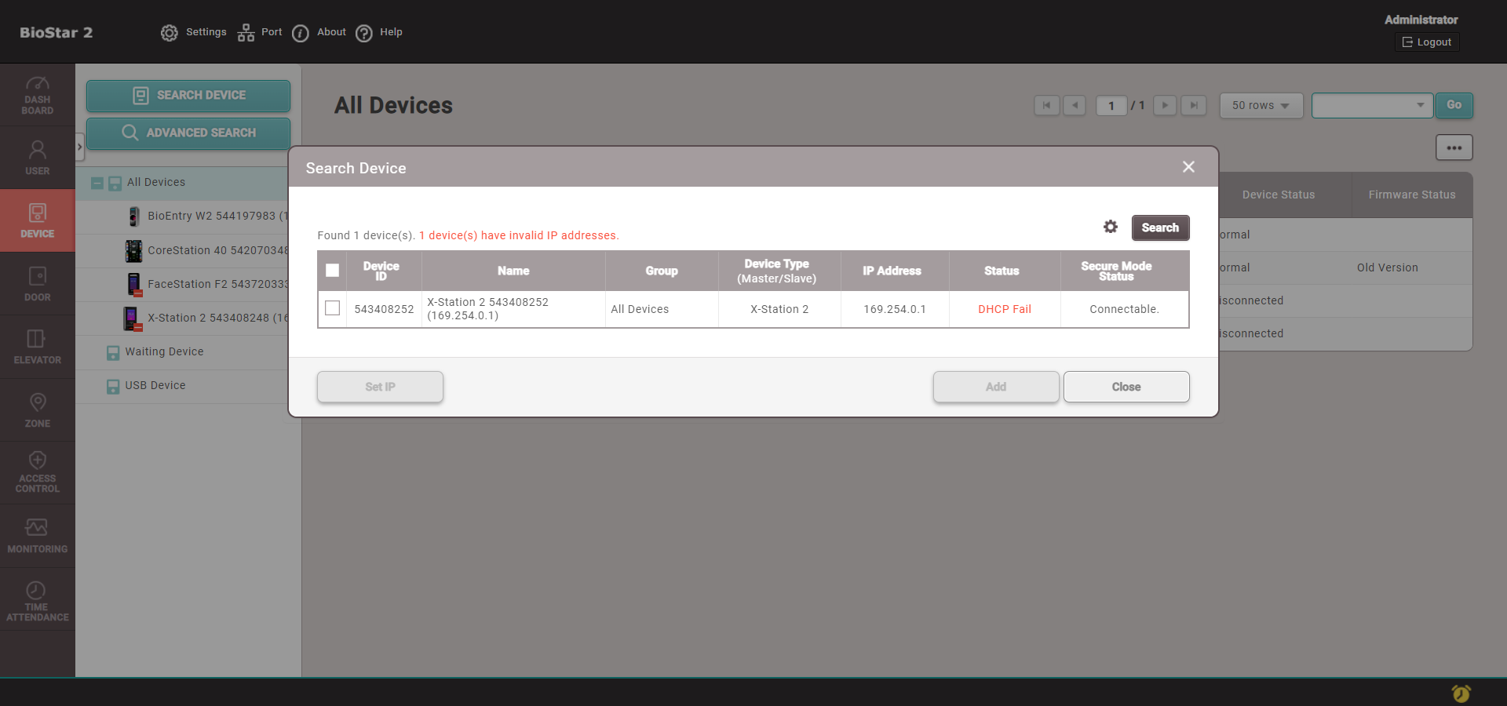
2. Next proceed to Airfob and create an account and a site, fill out all the necessary details.
Then you can add a user to the Airfob portal and remember the auto generated card id Number
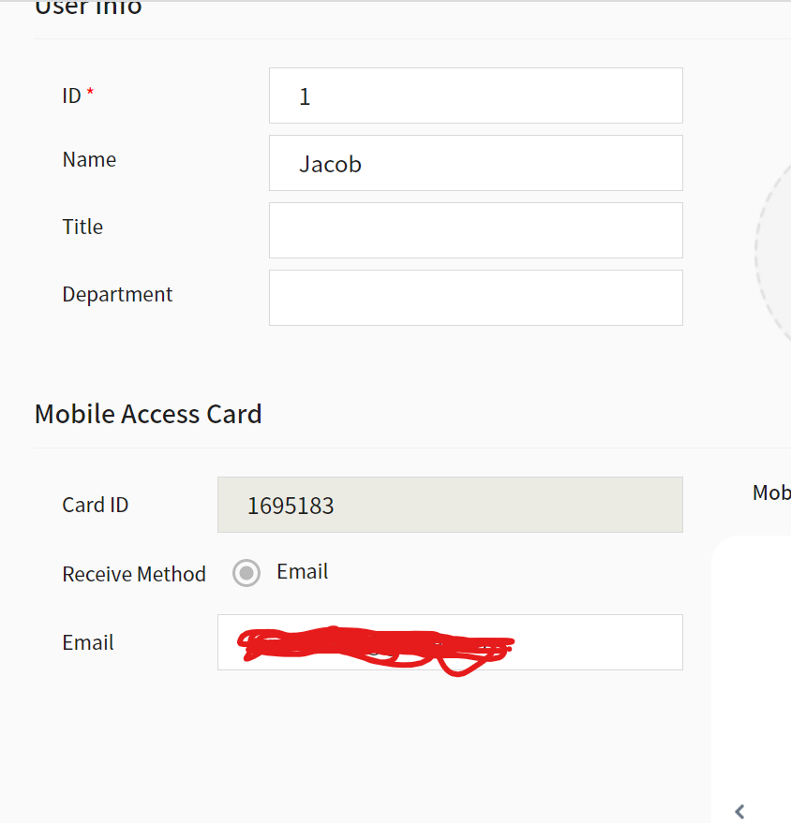
Next on the Airfob portal go into settings>site and copy the ID of the site code you will need this to link the Airfob to your Biostar server. Then after you have emailed the credential, you will need to activate this (please ensure you have the Airfob app preinstalled on your smartphone) by clicking the link in the email
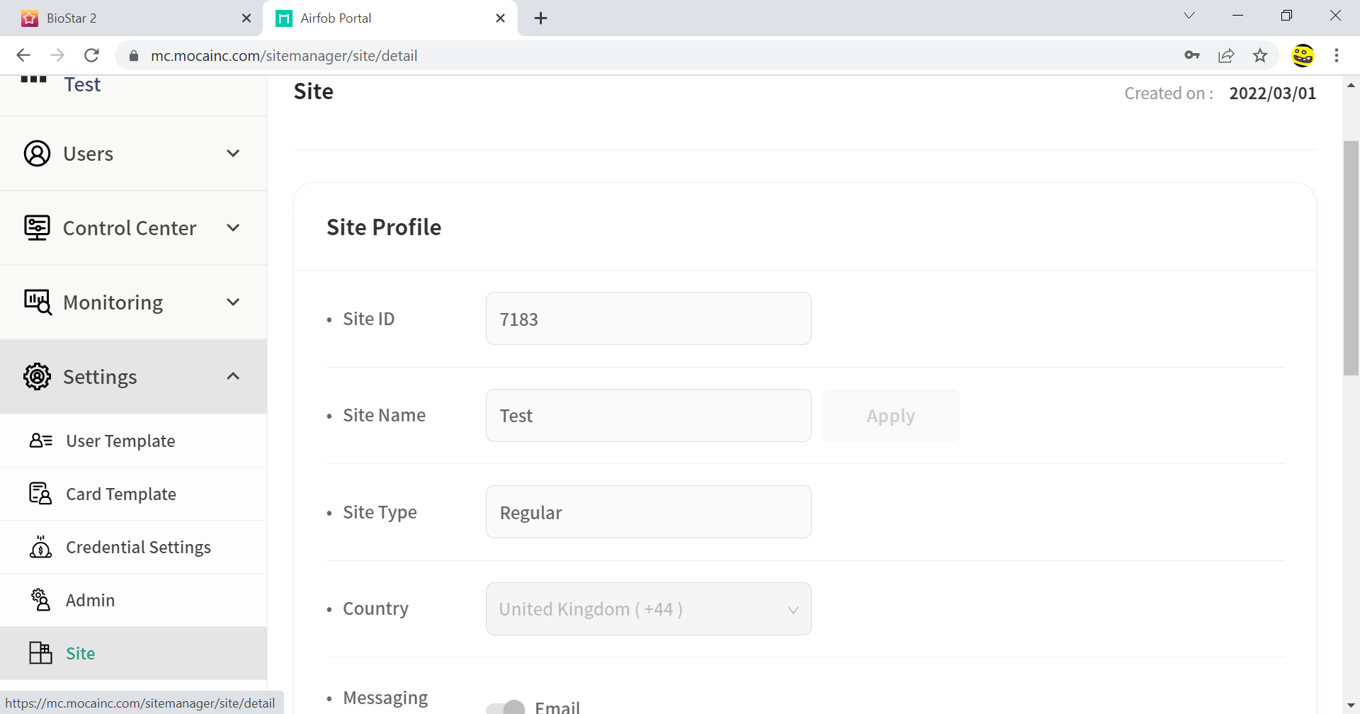
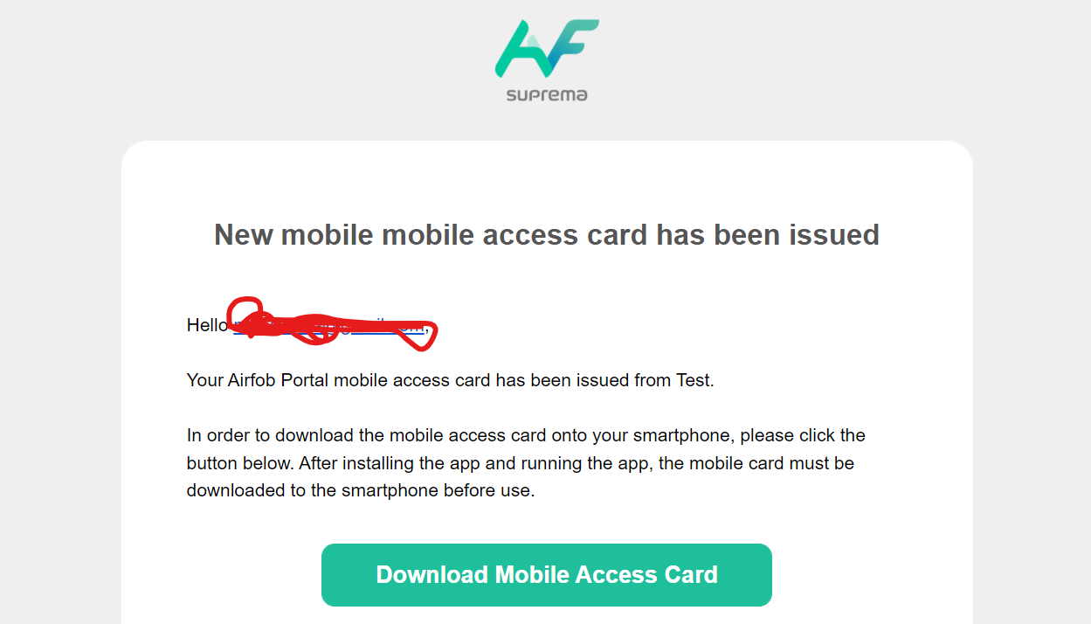
Next at the top of the screen go to settings>mobile credential. Fill out all the details, the username and password are the Airfob account details and use the previously mentioned site ID and click connect

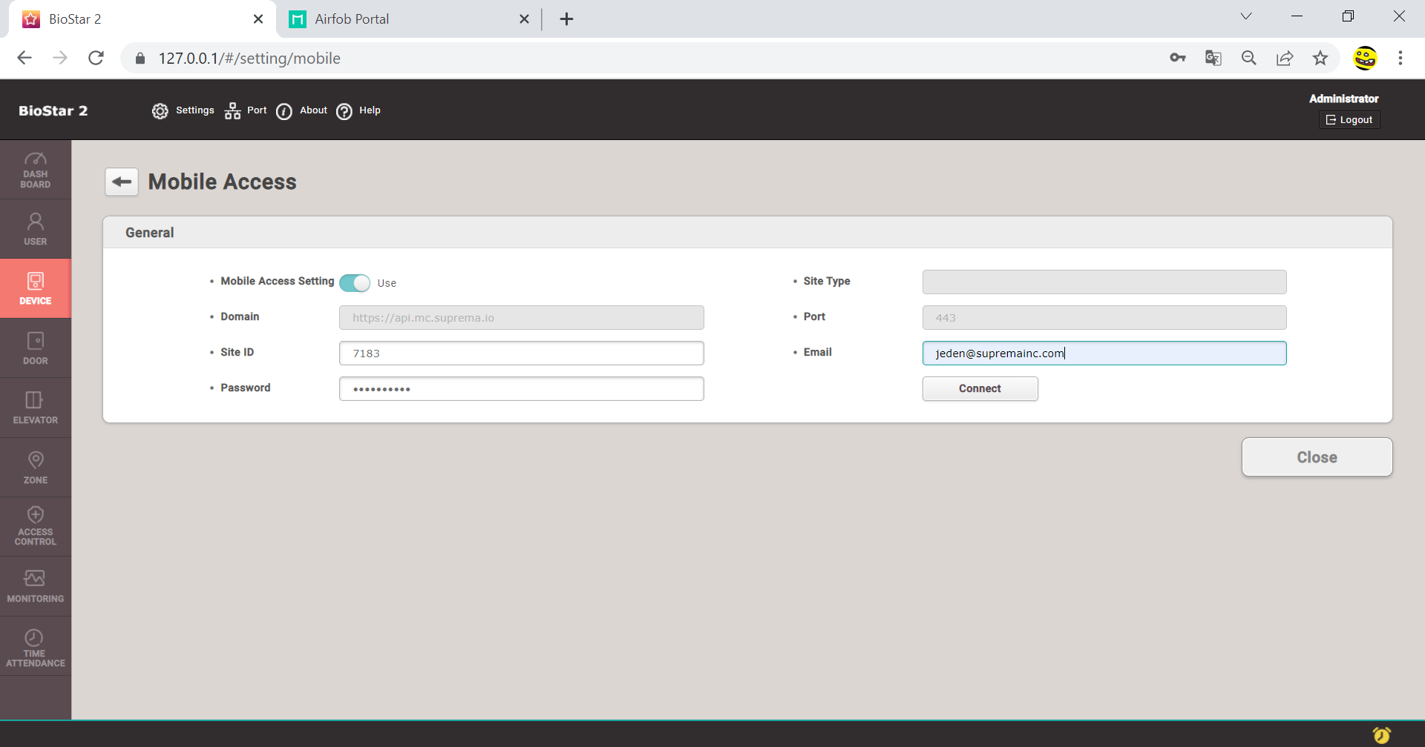
Then after the link has been created successfully add a device you want to use in order to link it
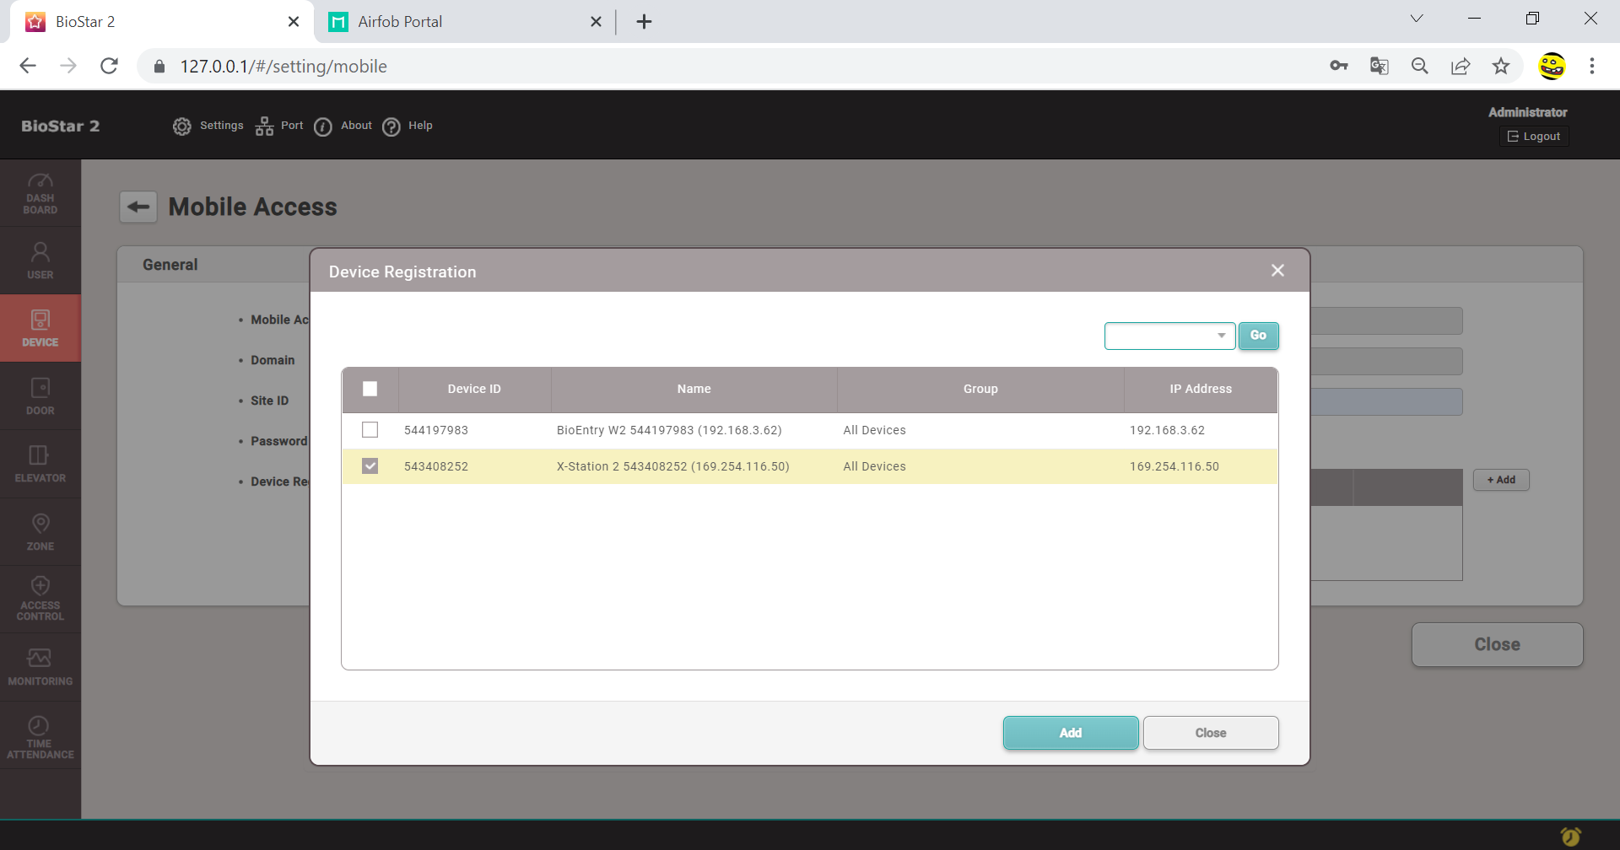
Next head to the user section and select the user you wish you add the mobile credential too, go to the bottom and select add card, select CSN card and “enter card manually” then enter the user ID from Airfob and click enrol. Apply the changes
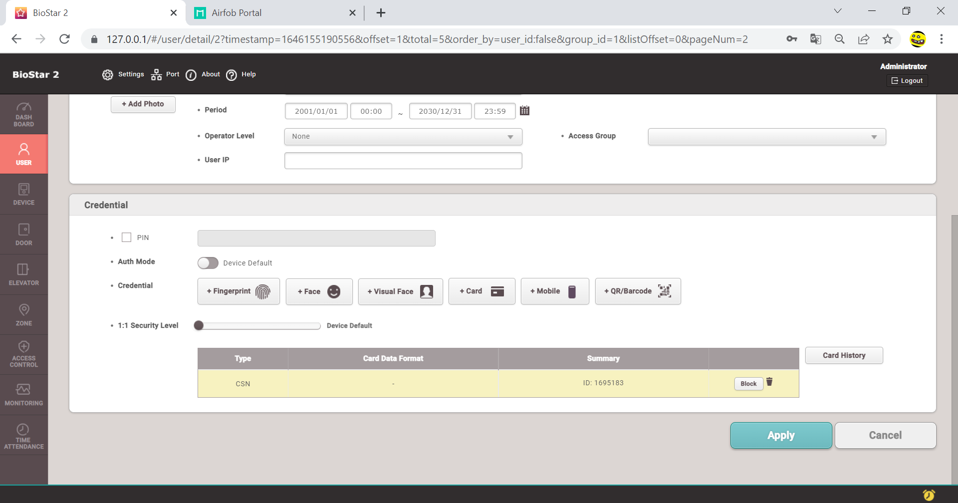
After you have added the mobile card to your Airfob app and added the card you can now hold your mobile to the xStation to authenticate.
